CubeSat EM Material Discharge Eval

Joshua Feldman

Michael Kim

Ian Poynter

Alejandro Torres

**Functional System Requirements**

REVISION – Draft

28 September 2023

Functional System Requirements

for

CubeSat EM Material Discharge Eval

Prepared by:

_____________________________

Author Date

Approved by:

_____________________________

Project Leader Date

_____________________________

John Lusher, P.E. Date

_____________________________

T/A Date

**Change Record**

| **Rev.** | **Date** | **Originator** | **Approvals** | **Description** |
| --- | --- | --- | --- | --- |
| - | 9/28/2023 | Ian Poynter |  | Draft Release |
| 1 | 12/3/2023 | Ian Poynter |  | End of Semester Revision |

**Table of Contents**

**Table of Contents 3**

**List of Tables 4**

**List of Figures 5**

**1.** **Introduction 6**

1.1. Purpose and Scope 6

1.2. Responsibility and Change Authority 6

**2.** **Applicable and Reference Documents 7**

2.1. Applicable Documents 7

2.2. Reference Documents 7

2.3. Order of Precedence 7

**3.** **Requirements 8**

3.1. System Definition 8

3.2. Characteristics 9

3.2.1. Functional / Performance Requirements 9

3.2.1.1 Accelerator Plate….………………………………………………………………..9

3.2.1.2 Shielding………..….………………………………………………………………..9

3.2.1.3 Microcontroller….….………………………………………………………………..9

3.2.2. Physical Characteristics 9

3.2.3. Electrical Characteristics 10

3.2.4. Environmental Requirements 11

3.2.5. Failure Propagation 12

**4.** **Support Requirements 13**

**Appendix A Acronyms and Abbreviations 14**

**Appendix B Definition of Terms 15**

**Appendix C Interface Control Documents 16**

**List of Tables**

**Table 1: Subsystems and Responsibility**………………………………………………….**6**

**Table 2: Applicable Documents**……………………………………………………………..**7**

**Table 3: Reference Documents**…………………………………………………………...…**7**

**List of Figures**

**Figure 1: Your Project Conceptual Image 1**

**Figure 2: Block Diagram of System 4**

# 

# Introduction

## Purpose and Scope

The purpose of this project is to design and build the prototype of the RIOT Drive that will have the capability to fit within 1U of a CubeSat with an emphasis on maintaining a low weight to reduce the costs for launch and maximize propulsion while in space. The prototype will be specifically designed to measure the data of different geometries and materials used to see the efficiency of each model. We will also design the power supply within the prototype to deliver power to the components of the RIOT Drive. Figure 1 shows a rough design of a modeled prototype with one of the geometries that is used.

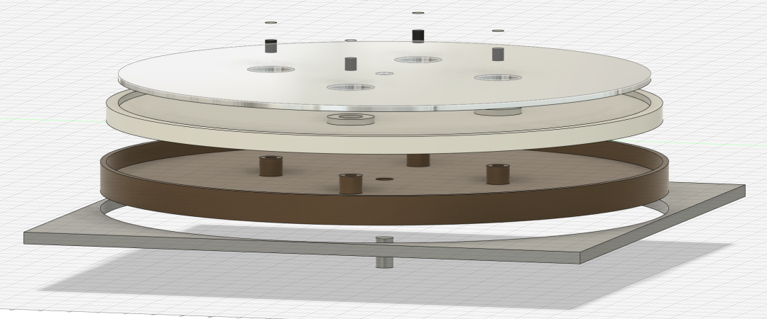

Figure 1: Model of Orbital Arc RIOT Drive

## Responsibility and Change Authority

The team leader, Ian Poyner, is responsible for ensuring all requirements for the system are met. Changes made to each subsystem are to be approved by the team leader and Professor John Lusher. Subsystem responsibility is as follows:

| **Subsystem** | **Responsibility** |
| --- | --- |
| High Potential Accelerator Modeling | Michael Kim |
| CubeSat Chassis Construction | Ian Poynter |
| Power Supply Circuit | Alejandro Torres |
| Microcontroller | Josh Feldman |

Table 1: Subsystems and Responsibility

# Applicable and Reference Documents

## Applicable Documents

The following documents, of the exact issue and revision shown, form a part of this specification to the extent specified herein:

| **Document Number** | **Revision/Release Date** | **Document Title** |
| --- | --- | --- |
| 19970027853 | Revision 4 - June 1997 | Outgassing Data for Selecting Spacecraft Materials |
| CP-CDS-R14.1 | Revision 14.1 - February 2022 | CubeSat Design Specifications |

Table 2: Applicable Documents

## Reference Documents

The following documents are reference documents utilized in the development of this specification. These documents do not form a part of this specification and are not controlled by their reference herein.

| **Document Number** | **Revision/Release Date** | **Document Title** |
| --- | --- | --- |
| 20210018053 | July 1, 2021 | Avionics Radiation Hardware Assurance (RHA) Guidelines |
| 19920003068 | September 1991 | NASA Reliability Preferred Practices for Design and Test |
| NPR 7120.10B | June 1, 2022 | Technical Standards for NASA Programs and Projects |

Table 3: Reference Documents

## Order of Precedence

In the event of a conflict between the text of this specification and an applicable document cited herein, the text of this specification takes precedence without any exceptions.

All specifications, standards, exhibits, drawings or other documents that are invoked as “applicable” in this specification are incorporated as cited. All documents that are referred to within an applicable report are considered to be for guidance and information only, except ICDs that have their relevant documents considered to be incorporated as cited.

# Requirements

## System Definition

Our project will be making the first functional prototype for the RIOT Drive, proposed by Orbital Arc. Our goal is to design power supply circuitry capable of delivering the necessary power to all components that would be present in a launch-ready system. We will also be collecting experimental data on the electric field produced by the different accelerator plate geometries and materials. Additional responsibilities include designing the microcontroller system to operate components such as the gas feed valve and pulse chargers, the design of the CubeSat chassis, and risk consideration calculations such as thermal, radiation, and outgassing.

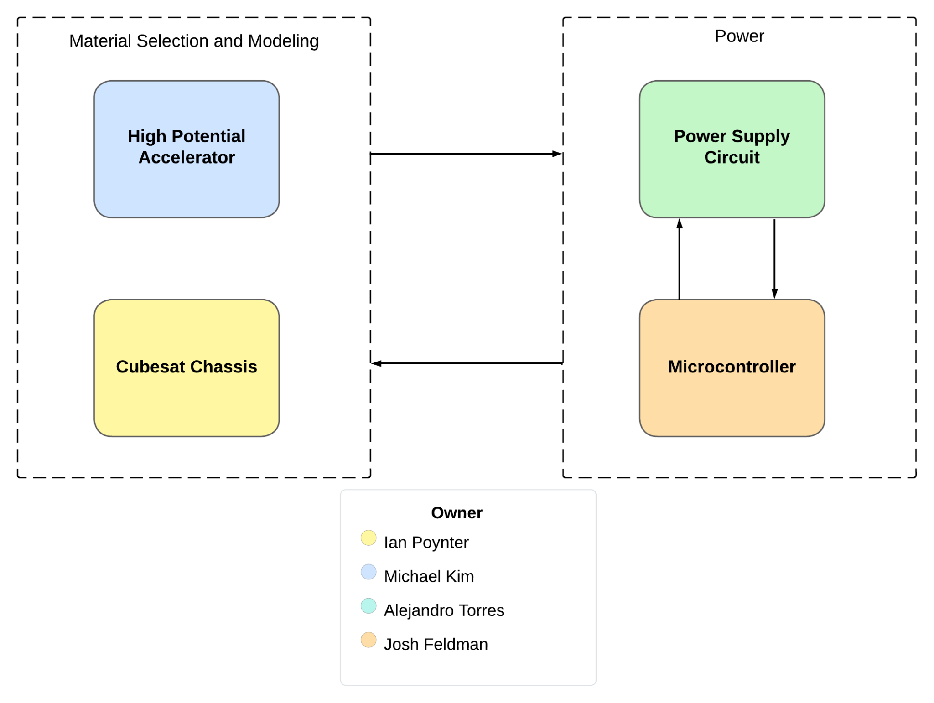Figure 2: Block Diagram of System

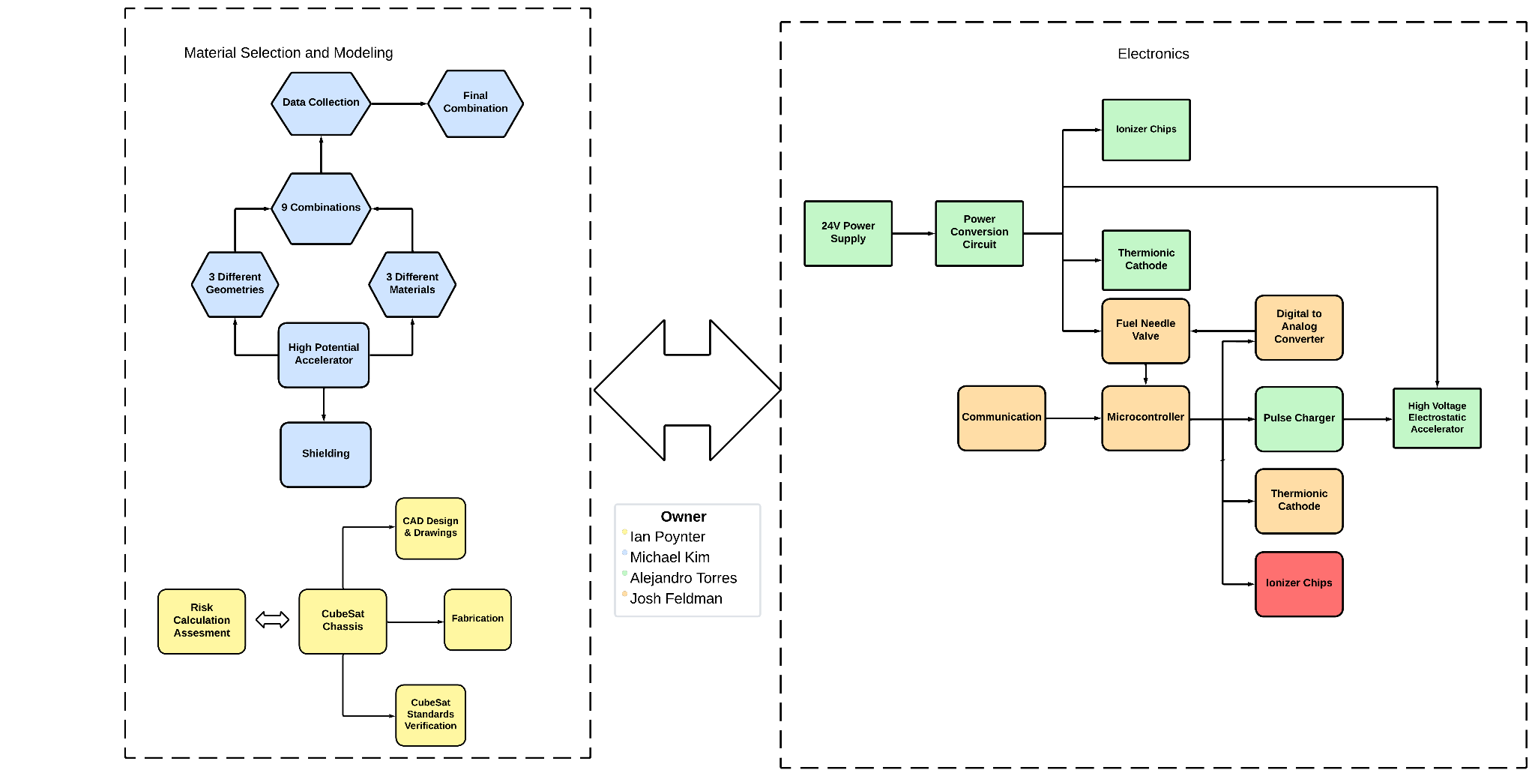

Figure 3: Expanded Block Diagram of Subsystems

The RIOT Drive prototype shall have 2 main components broken down into 2 subsystems each. The high potential accelerator shall include the construction of the plate that holds the high voltage for accelerating the ions, and shielding of the software from the voltage on the plate. This subsystem will interface with the chassis for mounting, the power circuit for charging the plate, and the microcontroller for enabling the plate and determining the amount of charge. The CubeSat chassis shall be constructed of material that can withstand space launch and travel. It will fit inside a CubeSat, and be constructed to mount the accelerator plate and shielding, and the power supply circuit. Ian Poynter will be creating the chassis out of aluminum 7075. The power supply circuit will take a 24VDC input and supply proper power to all components, including the pulse charger for the accelerator plate, the thermionic cathode, the ionizer, the gas feed control, and the microcontroller. The microcontroller will control charging the accelerator plate, the gas feed control, the ionizer, and the thermionic cathode.

## Characteristics

### Functional / Performance Requirements

#### Accelerator Plate

The RIOT Drive accelerator shall sustain a charge of 40kV and reach up to 100 kV.

*Rationale: This is the highest voltage our RIOT Drive would ever need, specified by Orbital Arc, so testing the maximum voltage ensures that lower voltages are sustainable.*

#### Shielding

The Accelerator shall be shielded from the electronics so the electronics can function without interference. Thermal and radiation shielding will need to be included in the internal electronics design.

*Rationale: This is required by the project for the power circuit and microcontroller to function in a space environment.*

* + - 1. **Microcontroller**

The microcontroller shall be able to regulate gas flow of the fuel, enable the accelerator, and time the pulse charger for charging the accelerator plates.

*Rationale: The microcontroller must interface with these components of the RIOT Drive for it to function properly.*

### Physical Characteristics

#### Mass

The total mass of the CubeSat prototype shall not exceed 2 kg. The mass of the power supply circuit shall be less than or equal to 200 grams. The mass of the chassis shall not exceed 200 grams.

*Rationale: The CubeSat total weight is specified by the CubeSat Design Specifications. The power supply weight is a requirement specified by our customer due to the size of the CubeSat and the power of the RIOT Drive.*

#### Volume Envelope

The volume envelope of the RIOT Drive shall be 10 cm in height, 10 cm in width, and 10 cm in length. The volume envelope of the power supply circuit shall be less than or equal to 2 cm in height, 10 cm in width, and 10 cm in length. Certain parts of the design, such as the battery or fuel tank, will be considered to be external to the 1U CubeSat. The chassis shall also undergo strength testing to ensure structural integrity.

*Rationale: This is a requirement specified by our customer due to constraints of a CubeSat which the RIOT Drive shall fit inside.*

#### Mounting

The mounting information for the RIOT Drive shall be designed to interface with a common CubeSat frame design.

*Rationale: This is a requirement specified by our customer due to the constraint of needing to be mounted inside a CubeSat.*

#### Accelerator Geometry and Material

The geometry and material for the RIOT Drive High Potential accelerator will be chosen from one of the tested combinations of 3 different geometries and 3 different materials.

*Rationale: This is to test out which combination can meet the required tasks and objectives of optimization of the accelerator the best.*

### Electrical Characteristics

#### Inputs

1. The presence or absence of any combination of the input signals in accordance with ICD specifications applied in any sequence shall not damage the RIOT Drive, or cause any malfunction, either when the unit is powered or when it is not.
2. No sequence of command shall damage the RIOT Drive, or cause any malfunction.

*Rationale: By design, should limit the chance of damage or malfunction by user/technician error.*

##### Power Consumption

1. The maximum peak power of the system shall be 50 watts.

*Rationale: This is a requirement specified by our customer due to the power demands of their system.*

##### Input Voltage Level

The input voltage level for the RIOT Drive shall be 24V .

*Rationale: This is a requirement specified by our customer due to the supply from the spacecraft*

##### External Commands

The RIOT Drive system shall document all external commands in the appropriate ICD.

*Rationale: The ICD will capture all interface details from the low-level electrical to the high-level packet format.*

#### Outputs

* + - * 1. **Output Levels**

1. The output voltage level of the accelerator plate shall reach a maximum of 100kV.
2. The output of the power supply circuit shall be as follows:
   1. 3-12V for the High Voltage Electrostatic Accelerator
   2. 33V for the Ionizer Chips
   3. 3-6V for the Thermionic Cathode
   4. 5V/3.3V for the Microcontroller

*Rationale: This is a requirement specified by the customer*

##### Diagnostic Output

The RIOT Drive prototype is designed as a proof of concept and will not include a diagnostic interface for debugging. Debugging shall be handled by an oscilloscope.

*Rationale: This project is a prototype and building a diagnostic interface is outside the scope of this project.*

#### Wiring

The RIOT Drive’s wiring will be done on a PCB design.

*Rationale: The PCB design will provide stability to the system.*

### Environmental Requirements

The RIOT Drive shall be designed to withstand and operate in the environments and laboratory tests specified in the following section.

*Rationale: This is a requirement specified by our customer due to constraints of their system in which the Search and Rescue System is integrating.*

#### Space Launch

The RIOT Drive’s power supply shall be designed to withstand the physical stresses of space launch.

*Rationale: The RIOT Drive is intended to be launched in space, so the system will have to withstand physical pressures that are caused during space launch.*

#### Thermal

The RIOT Drive’s power supply shall be designed to withstand the thermal stresses from space and space launch. Component selection will also take into consideration thermal effects.

*Rationale: The RIOT Drive will be in space, so it must withstand any temperatures that will be reached in outer space*

#### Outgassing in Vacuum

The materials exposed in outer space shall have TML must be less than 1% and the CVCM must be less than 0.1% as specified by document 19970027853.

*Rationale: This is a constraint provided by NASA’s requirements for material outgassing in outer space.*

### Failure Propagation

By following safe coding practices, any exceptions will be caught and will throw errors if the system cannot recover. The system will be tested rigorously to ensure that the code functions properly for the prototype. As this system is only a prototype and lacks many features that will be designed by Orbital Arc, Built In Testing is beyond the scope of this project.

# Support Requirements

For our prototype, support will be provided to Orbital Arc through documentation such as the Functional System Requirements and Interface Control Document. In the future, users will be provided with support through instruction documents from Orbital Arc and meetings with Orbital Arc and the consumer company to discuss how the RIOT Drive will be used. Electronic support will be implemented through the on-board computers of the spacecraft.

# Appendix A: Acronyms and Abbreviations

kV kilovolts (1000 Volts)

VDC Volts Direct Current

ICD Interface Control Document

RIOT Relativistic Ion Thrust

TML Total Mass Loss

CVCM Collected Volatile Condensable Material

1U 1 unit

# Appendix B: Definition of Terms

CubeSat: A standard set by Cal Poly, the CubeSat platform standardizes nanosatellites into a 10cm x 10cm x 10cm cube (1U) for delivering payloads to outer space.